INTERNSHIP TASKS

Name : S. Deva Manikanta

Clg Id : 12119003

Course : Python

Org : IGIAT – VSKP

Date : 12-04-2024

Day 9: EXERCISE – 9

Exercise Level 1

#Task 1:

#Get user input, and print the appropriate message if user is 18 or older give feedback : You are old enough to drive. If below 18 give feedback to wait for missing amount of years

try:

    age = int(input("Enter your age: "))

    if(age >= 18):

        print("You are old enough to drive")*;*

    else:

        print(f"You need {18-age} more years to learn to drive")*;*

except ValueError as T:

    print("Invalid Input is given")*;*

#Task 2:

#Compare the values of my_age and your_age using if..else. Who is older me or you?, use input function to get the age as input. You can use a nested condition to print 'year' for 1 year diff. in age, and 'years' for bigger differences and a custom text if my_age =  your_age

my_age = 20*;*

try:

    your_age = int(input("Enter your age: "))*;*

    if(my_age < your_age):

        age_diff = your_age - my_age*;*

        if(age_diff > 1):

            print("You are ", age_diff, " years older than me.")*;*

        if((age_diff <= 1) and (age_diff != 0)):

            print("You are ", age_diff, " year older than me.")*;*

    elif(my_age > your_age):

        age_diff = my_age - your_age*;*

        if(age_diff > 1):

            print("I am ", age_diff, " years older than you")*;*

        if((age_diff <= 1) and (age_diff != 0)):

            print("I am ", age_diff, " year older than you")*;*

    else:

        print("Your age is equal to mine!")*;*

except ValueError as e:

    print("Invalid Input")*;*

#Task 3:

#Get two number from the user input. If a is greater than b return a is greater than b, if a is less than b return a is smaller than b, else a is equal to b

try:

    a = int(input("Enter the number one : "))*;*

    b = int(input("Enter the number two : "))*;*

    if(a > b):

        print(a , "is greater than", b)*;*

    elif(b > a):

        print(a, "is less than", b);

    else:

        print(a, "is equal to", b)*;*

except ValueError as e:

    print("Invalid Input")*;*

**Outputs:**

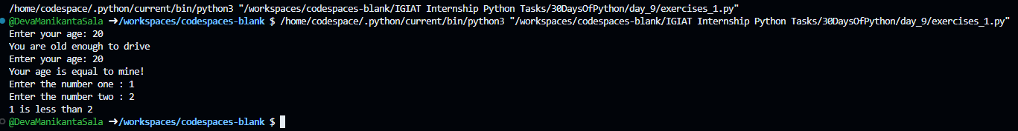

Exercise Level 2

#Task 1

# Write a code which gives grade to students according to their scores

try:

    score = int(input("Enter your score: "))*;*

    if(score <= 100 and score >= 80):

        print("Grade : A")*;*

    elif(score <= 89 and score >= 70):

        print("Grade : B")*;*

    elif(score <= 69 and score >= 60):

        print("Grade : C")*;*

    elif(score <= 59 and score >= 50):

        print("Grade : D")*;*

    else:

        print("Grade : F")*;*

except ValueError as e:

    print("Invalid Input is given")*;*

#Task 2

# Check if the season is Autumn, Winter, Spring or Summer.

#     September, October, November - Autumn

#     December, January, February - Winter

#     March, April, May - Spring

#     June, July, August - Summer

try:

    Summer = {'January' : 1, 'February' : 2, 'December' : 12}

    Autumn = {'September' : 9, 'October' : 10, 'November' : 11}

    Winter = {'March' : 3, 'April' : 4, 'May' : 5}

    Spring = {'June' : 6, 'July' : 7, 'August' : 8}

    month = input("Enter your month or month number: ")*;*

    if(month.isnumeric()):

        month = int(month)*;*

        if(month in Summer.values()):

            print(month, "is in Summer Season")*;*

        elif(month in Autumn.values()):

            print(month, "is in Autumn Season")*;*

        elif(month in Winter.values()):

            print(month, "is in Winter Season")*;*

        elif(month in Spring.values()):

            print(month, "is in Spring Season")*;*

        else:

            print(month, "is invalid month!")*;*

    else:

        if(month in Summer.keys()):

            print(month, "is in Summer Season")*;*

        elif(month in Autumn.keys()):

            print(month, "is in Autumn Season")*;*

        elif(month in Winter.keys()):

            print(month, "is in Winter Season")*;*

        elif(month in Spring.keys()):

            print(month, "is in Spring Season")*;*

        else:

            print(month, "is invalid month!")*;*

except Exception as e:

    print("Invalid Input!")*;*

#Task 3:

#Based on the user input if a fruit doesn't exist in the list add the fruit to the list and print the modified list. If the fruit exists print - That fruit already exist in the list

fruits = ['banana', 'orange', 'mango', 'lemon']*;*

try:

    fruit = input("Enter the fruit name : ")*;*

    if(fruit.isnumeric() or fruit.isdecimal() or fruit.isdigit()):

        raise ValueError*;*

    elif(fruit.lower() in fruits):

        print("That fruit already exist in the list")*;*

    else:

        fruits.append(fruit)*;*

        print("New Fruit added!")*;*

        print("New List :", fruits)*;*

except ValueError as E:

    print("Invalid Fruit Name!")*;*

**Output:**

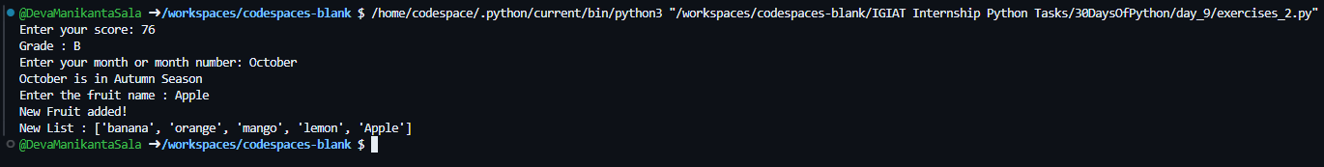

Exercise Level 3

person = {

    'first_name' : 'Deva Manikanta',

    'last_name' : 'Sala',

    'age' : 20,

    'country' : 'India',

    'is_married' : False,

    'skills' : ['Java', 'Python', 'Html', 'CSS', 'Sqlite', 'JavaScript'],

    'address' : {

        'colony' : 'APHB colony',

        'pincode' : '534260'

    }

}

#Question 1: Check if person dictionary has skills key, if so print out the middle skill in the skills list

try:

    if('skills' in person.keys()):

        print("Middle Skill : ", person['skills'][(int(len(person['skills']) / 2))])*;*

except Exception as E:

    pass*;*

#Question 2: Check if the person dictionary has skills key, if so check if the person has 'Python' skill and print out the result.

if('skills' in person.keys()):

    if('Python' in person['skills']):

        print("Yes! He has python skill")*;*

    else:

        print("No! He doesn't has python skill")*;*

else:

    print("There are no skills of this person!")*;*

#Question 3: If a person skills has only JavaScript and React print he is a frontend dev,

# if the person skill has Node, Python, SQLite/MySql print he is a backend dev,

# if he has both frontend and backend skills the print fullstack developer

# else print he holds unknown title

if('JavaScript' in person['skills'] and 'React' in person['skills']):

        if('Node' in person['skills'] and 'Python' in person['skills'] and ('Sqlite' in person['skills'] or 'Mysql' in person['skills'])):

            print("He is a Full Stack Developer")*;*

        else:

            print("He is a Frontend Developer")*;*

elif('Node' in person['skills'] and 'Python' in person['skills'] and ('Sqlite' in person['skills'] or 'Mysql' in person['skills'])):

    print("He is a Backend Developer")*;*

else:

    print("Unknown Title")*;*

#Question 4: If the person is married and if he lives in Finland, print the information

if(person['is_married'] and person['country'] == 'Finland'):

    print("Yes! The person is married and lives in Finland!")*;*

elif(person['is_married'] == False and person['country'] != 'Finland'):

    print("No! The person is not married and doesn't lives in Finland!")*;*

    print("He lives in", person['country'])*;*

else:

    print("There is no appropriate information!")*;*

**Output:**

